HIGH-EFFICIENCY BRIDGELESS THREE-LEVEL POWER FACTOR CORRECTION RECTIFIER
ABSTRACT
A high-efficiency bridgeless three-level power factor correction (PFC) rectifier is proposed. The circuit configuration of the proposed rectifier consists of four metal oxide semiconductor field-effect transistor (MOSFET) switches, and the reverse recovery problems of the switches are eliminated. Also, the proposed rectifier with three voltage levels reduces the power losses, harmonic components, voltage ratings, and electromagnetic interference. To control the grid current and the output voltage effectively, a feed-forward nominal voltage compensator with the mode selector is developed; by presetting the operating point of the grid voltage, this compensator improves the control environment. Thus, the proposed three-level PFC rectifier with developed control algorithm provides high power quality and high efficiency of 99.05%. Experimental results based on a 1-kW prototype are provided to evaluate its performance and verify the analysis.

BLOCK DIAGRAM FOR PROPOSED SYSTEM
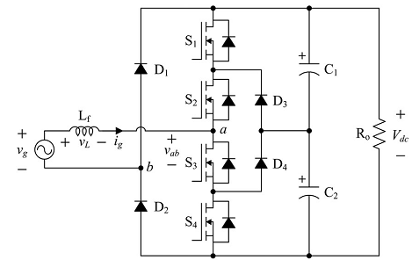
Fig. 1. Circuit diagram of the proposed rectifier.
.
DESIGNG SOFTWARE AND TOOLS:
MAT LAB /SIMULATION Software and simu power systems tools are used. Mainly control system tools, power electronics and electrical elements tools are used.

